GIT Installation and Bit Bucket Signup Guide:-

1. Get the “GitExtensions246SetupComplete.msi” from “P:\Development\ReleaseManagement\SCMTools\GIT\”
2. Right Click on the .msi file and open it as Run As Administrator
3. Click Next

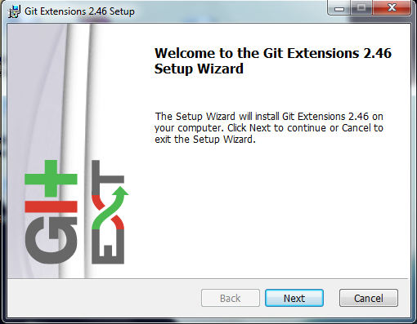

1. Select “Install for all Users of this machine” and click Next

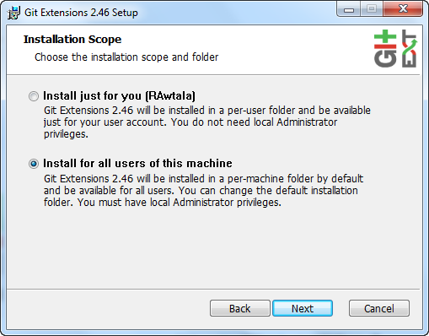

1. Check “Install MysysGit” and “Install KDiff” as shown in the below screenshotsi

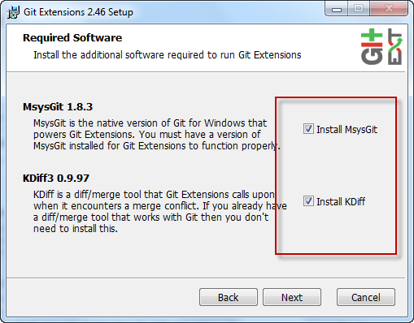

1. Click Next

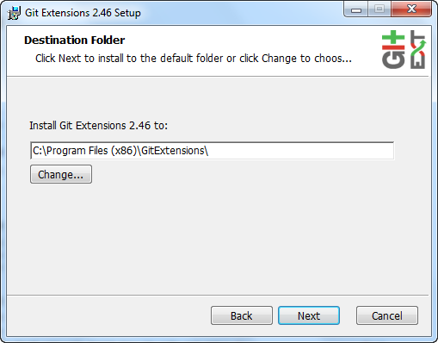

1. Click Next

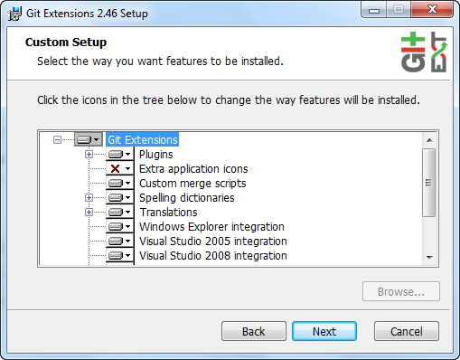

1. Select “PuTTY(plink.exe)” and Click Next

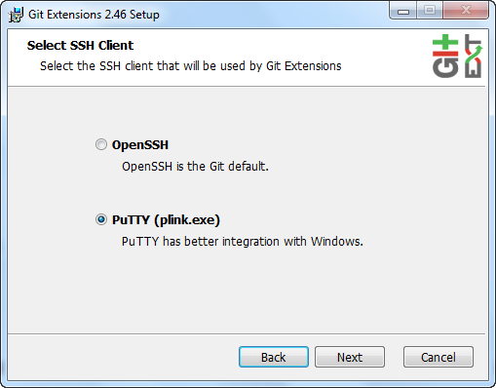

1. Click Install

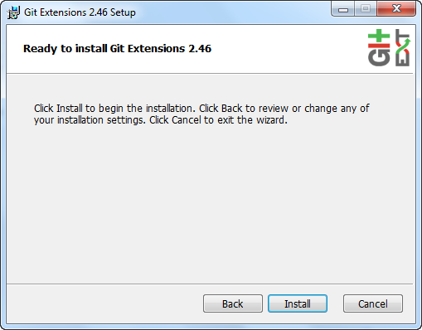

1. Select Language(English) and Click Next
2. Accept the terms and conditions by clicking “I Agree”

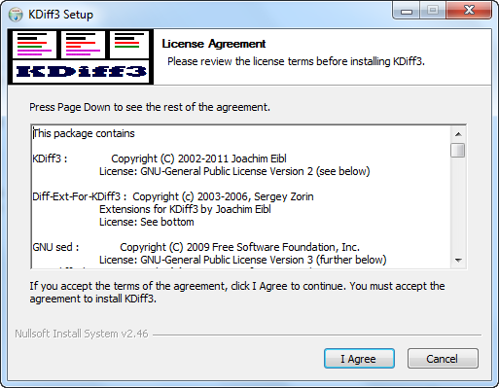

1. Click Next

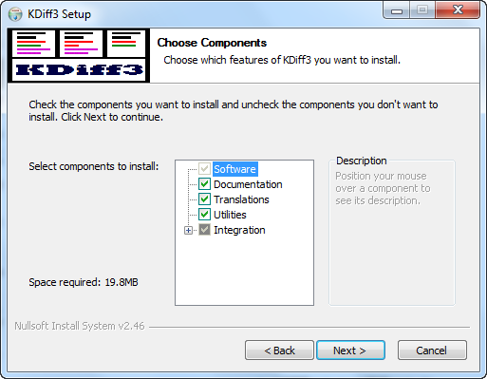

1. Click Next

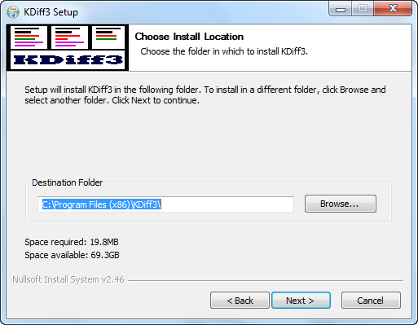

1. Click Next

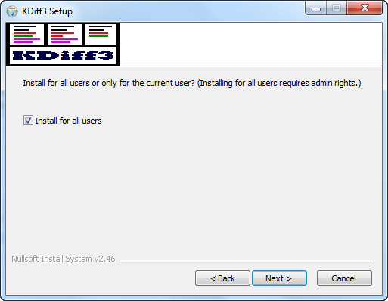

1. Click Install

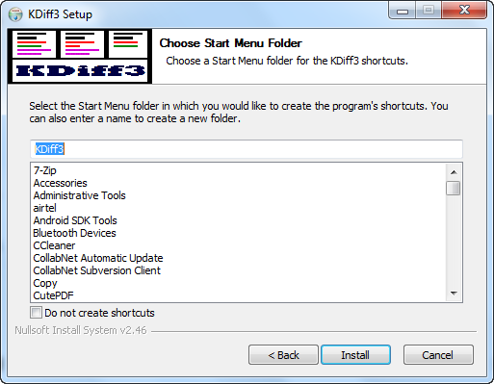

1. Click Finish

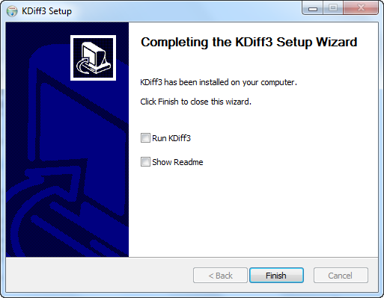

1. Click Next

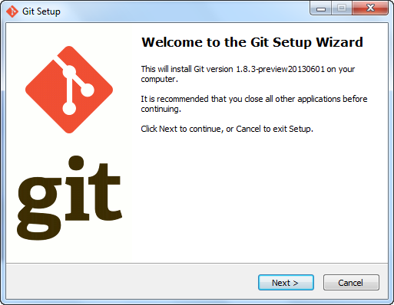

1. Click Next

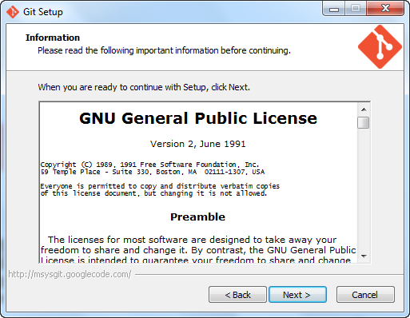

1. Click Next

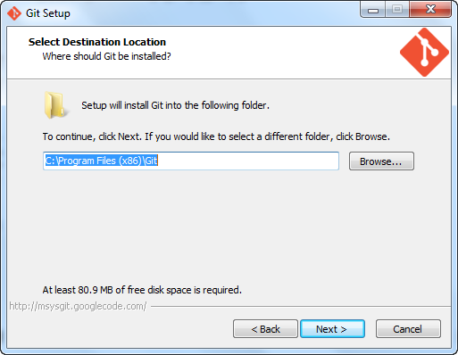

1. Click Next

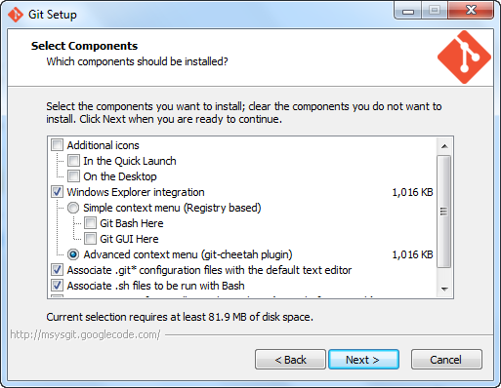

1. Click Next

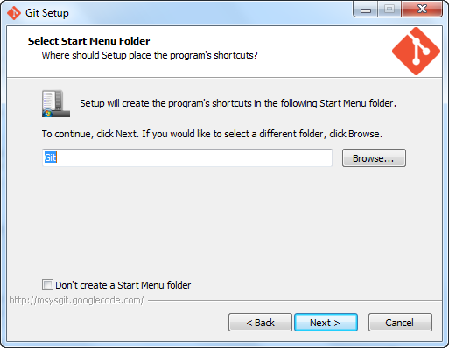

1. Select “ Use Git Bash Only” and Click Next

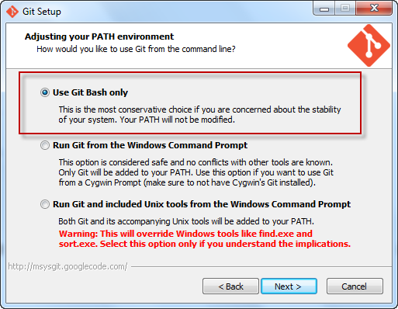

1. Select “Checkout as-is, Commit as-is” and click Next

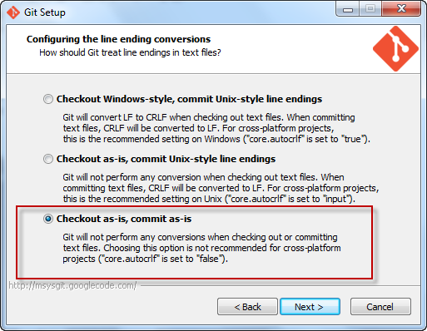

1. Click Finish

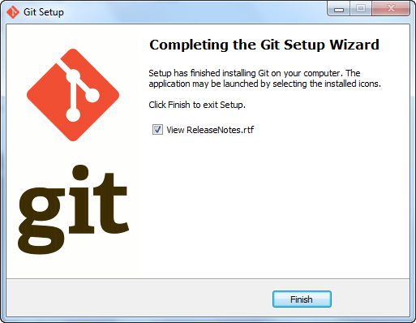

1. Click Finish

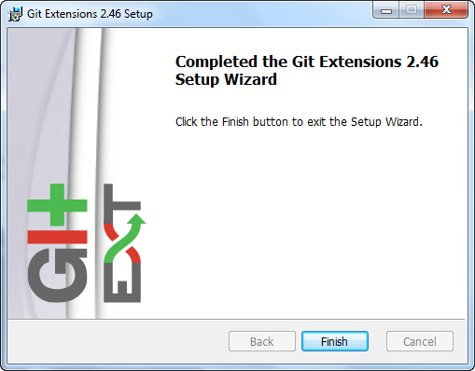

1. Open Visual Studio 2010 and goto Tools 🡪 Extension Manager…

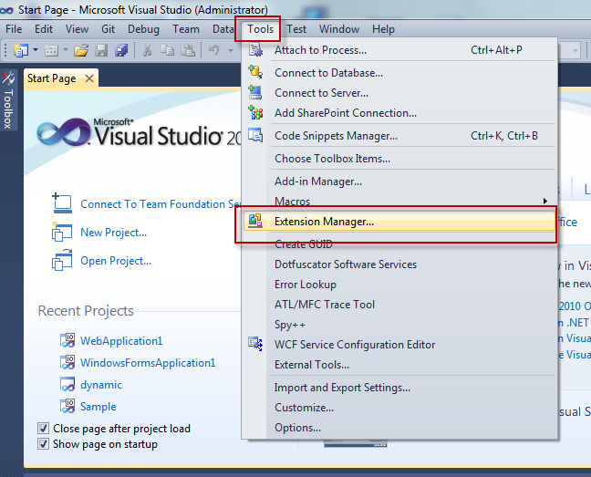

1. Select Online Gallery on the left Panel and search for “Git Source Control Provider” and click on Download and then Install.

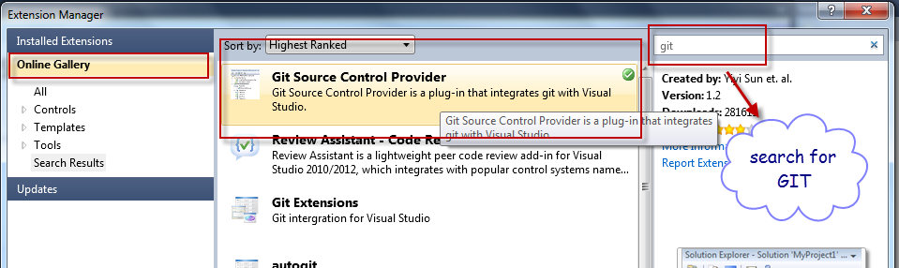

1. Creating Bit Bucket Account:- Launch the url: <https://bitbucket.org/hostanalytics>

In Browser and click on “Sign up”

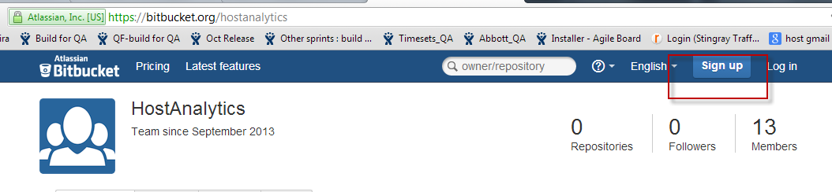

1. Select account type as “Individual” and provide your details

Note:- please add ”_HA” at the end of your username like ”rawtala_HA”

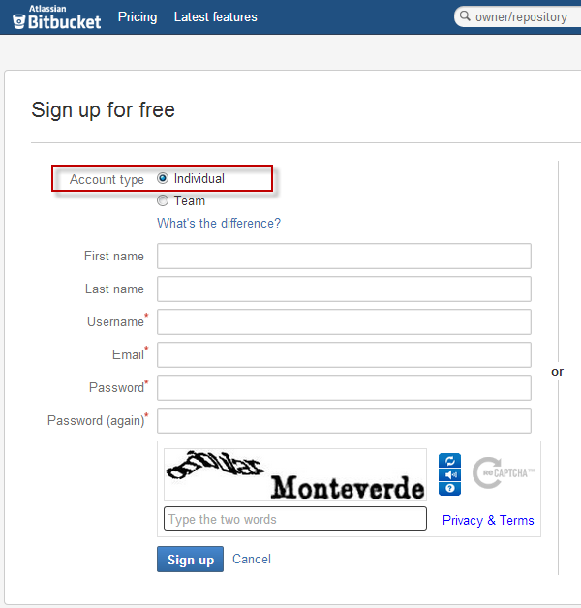

At any point of time if you face any issues, please feel free to contact Nikhil Gupta or Ramesh Reddy for further assistance.